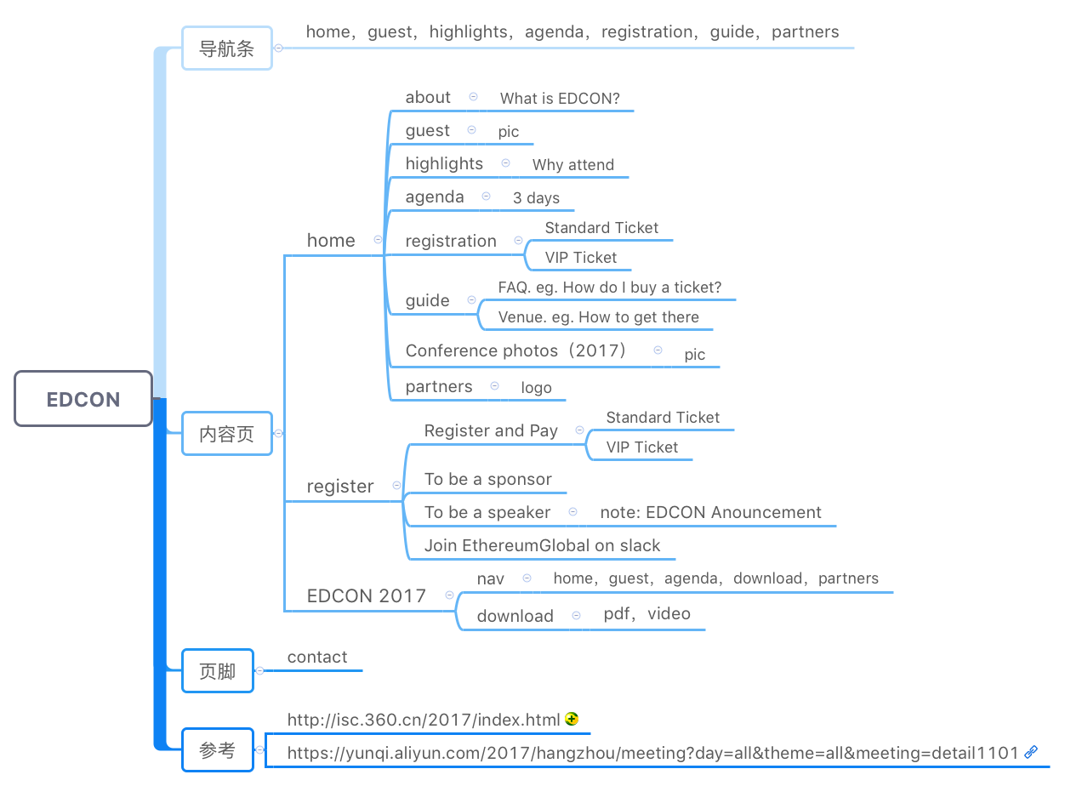**EDCON TORONTO 2018 WEB CONTENT**

**HOME:**

**1. ABOUT**

The EDCON (Ethereum Development Conference) is the global conference series organized by LinkTime for the purpose to discuss the updated Ethereum Blockchain technologies, current trends, policies as well as the future Ethereum applications.

EDCON Toronto will take place in Ted Rogers School of Management at Ryerson University, Toronto, Canada on May 2-May 5, 2018. The conference will cover Ethereum technology and research (Pos, Scalability, Privacy), the Ethereum-based applications in 2017 and Hackason Competition.

**2. GUEST:** TBD

**3. HIGHLIGHTS**

1. Topic: TBD

2. Why Attend?

1. Get inspired and Seize the opportunities of the Next-Generation Technology.

Blockchain is indeed the Next-Generation Technology with an increasing public awareness in 2017. Ethereum certainly plays a significant role in the Blockchain development. The conference therefore gathers worldwide experts, investors, and founders from 25 countries over 100 cities, giving you a glimpse into the future trends of the Blockchain technology, and inspiring you to the innovation and helping you find your business partners.

2. Connect with entrepreneurs, investors, researchers and developers.

EDCON Toronto will make you excited as we provide the opportunities to communicate with passionate, inspiring and creative developers, to exchange your thoughts with potential business partners at the sub-conferences, and allow the teams to compete in Hackason to win honorable prizes. You could therefore find trustworthy talents or business partners to work with in the long-run.

3. Global talent database

We spare all efforts in building the global talent database. You will meet the top talents from the world and networking with them.

4. Meet the Communities in the fascinating City, Toronto

Canada boasts incredible support for entrepreneurs, both homegrown and international. As a result, the encouraging environment will stimulate numerous business opportunities for entrepreneurs, researchers, developers and investors.

**4. AGENDA**

1. 1ST DAY **MAIN CONFERENCE:**

|  |  |  |  |
| --- | --- | --- | --- |
| **MAIN CONFERENCE** | **TIME** | **AGENDA** | **TOPICS (The orders might be adjusted)** |
| MAY 3, AM | Ethereum Development and Research |  |
| MAY 3, PM | Latest Technologies Exchange |  |
| MAY 4, AM | Discussions on Technologies in Ethereum-based Applications |  |
| MAY 4, PM |  |
| MAY 5, AM | Ethereum Startup Exchanges |  |
| MAY 5, PM | New Products Launch |  |
| MAY 5, Evening | Fun and Social | Cocktail Party |

2. 2ND DAY **SUB-CONFERENCE**

|  |  |  |  |
| --- | --- | --- | --- |
| **SUB-CONFERENCE** | **DATE** | **TIME** | **TOPICS (The orders might be adjusted)** |
| MAY 4 | 10:00-12:00 | **Deep dive into Ethereum:**  Core developers forum  **Guests:**  Vitalik Buterin and other Ethereum core developers  **Participants:**  Core developers, Individuals or organizations interested in researching or want to ask questions about Ethereum  **How to participate:**  VIP ticket, Up to 100 participants |
| 12:00-14:00 | **Startups, Investment and Financing:**   * Entrepreneurs and investors forum * Go-to-Market strategies for Ethereum-based companies（marketing for decentralized startups）   **Guests:**  Investors, Investment companies  **Participants:**  Startups, Investors, Investment companies  **How to participate:**  VIP ticket, Up to 100 participants |
| 14:00-16:00 | **Talents Database:**  Database builders and talents seekers forum  **Guests:**  Linktime Tech and other companies  **Participants:**  Talents, Talents seekers  **How to participate:**  VIP ticket, Up to 100 participants |
| 16:00-18:00 | **Ethereum Community Building:**  Ethereum community global representatives forum  **Guests:**  Ethereum community global representatives  **Participants:**  Ethereum volunteers, European Efans, Individuals and organizations who want to cooperate with or sponsor groups in the Ethereum community  **How to participate:**  Ticket for the main conference |

3. 3RD DAY **HACKASON COMPETITION:**

|  |  |
| --- | --- |
| **HACKASON COMPETITION** | **DATE** |
| MAY 4- MAY 5  24 HOURS |
|
|
|

**5. REGISTRATION**

1. Ticket Info.

General Admission: $700 (USD)

Early Bird (the First 100 Tickets): $560 (USD)

Student Ticket: $210 (USD)

Ticket for Developers: $350 (USD)

**6. GUIDE**

1. FAQ: TBD

2. VENUE:

The Ted Rogers School of Management（TRSM） at Ryerson University is Canada's leading diverse, entrepreneurial business school centered in an urban learning environment.

TRSM is developing collaborative, creative leaders who will drive 21st century business forward while making a positive impact on society.

A pioneer in practical, career-focused training, TRSM is at the cutting edge of entrepreneurial, socially conscious and innovative approaches to business.

The Conference focuses on technology, innovation, finance and targets at a better communication and cooperation between developers, startups, investors and Efans. The conference would not be successful without the support of TRSM, we would like to give our sincere thanks for Ryerson University’s help and cooperation.

**7. PARTNERS**: TBD

About Us:

LinkTime is a startup that primarily develops applications on Ethereum and provides Ethereum-based blockchain and smart contract solutions. LinkTime works closely with core Ethereum developers and researchers, and it helps to advance the Ethereum ecosystem through technological development, training and promotions.